|  |  |  |  |  |  |  |  |  |
| --- | --- | --- | --- | --- | --- | --- | --- | --- |
| |  | | --- | | Samsung S-SOUNDBAR S61B/XV soundbar | | D:\_TUMA SOUND\Hi Fi sound\7_18_9.jpg |  |  |  |  |  | | --- | --- | --- | --- | | D:\_TUMA SOUND\Hi Fi sound\8_12_36.jpg | D:\_TUMA SOUND\Hi Fi sound\5_35_10.jpg | D:\_TUMA SOUND\Hi Fi sound\1_74_9.jpg |  | |  | **Featured information:**   * Dolby Atmos standard sound technology and DTS Virtual provide realistic, vivid sound. * Power up to 200W helps the sound resonate vividly in every detail * Connect up to 7 speakers at the same time to expand the sound space * Quick and easy control via One Remote control * Connecting to many peripheral devices increases convenience   **Price: 1200$**  **Specifications:**   * **Power capacity:** 200W * **Bluetooth:** Yes * **Audio technology:** Dolby Atmos/DTS Virtual:X, Q-symphony * **Weight:** 3.8 kg |

**Description:**

#### **Audio technology**

- Dolby Atmos/DTS:X technology with modern wireless surround sound, strong configuration, reproducing and improving sound quality even with 3D standards.

- Q-Symphony technology links soundbars and TV speakers for powerful, resonant sound so you can listen to vibrant music and watch sports shows more attractively and excitedly.

- The integrated center speaker balances all sounds, helping listeners not miss any dialogue of the characters in the movie. Passive speaker membrane helps optimize bass, creating thick, deep bass.

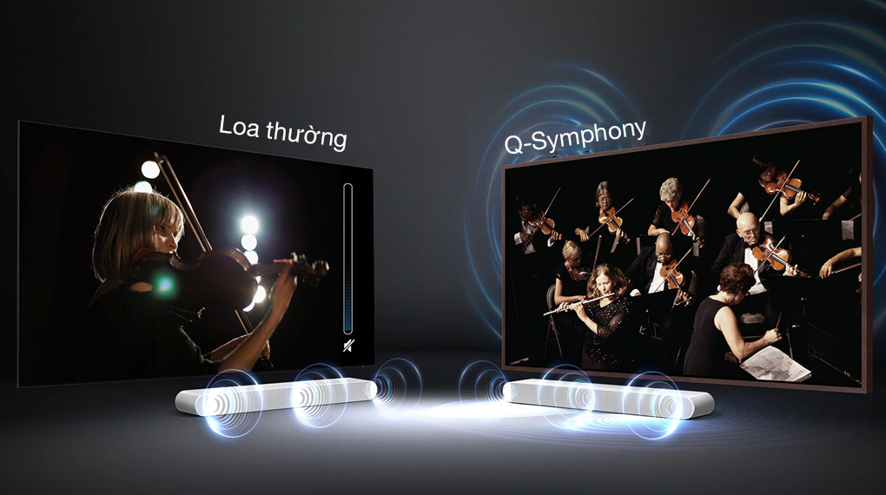

#### **Wattage**

Delivers high sound quality, creating a surround sound space that covers all senses with a total powerful speaker capacity of 200W and a 5-channel system with 4 Woofer speakers and 3 Treb speakers designed inside a compact speaker bar. only.

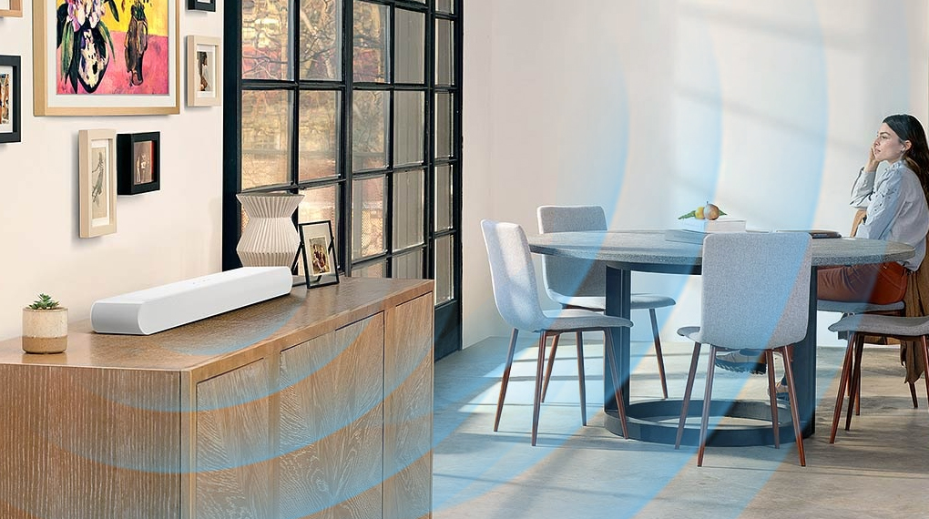

#### **Control**

In addition to the control panel on the speaker body, you can also use One Remote Control to turn on/off, adjust the volume and other functions of the device easily, without having to move near the speaker.

